Basics of Entomology

ENTOMOLOGY:
➢ Entomology is a branch of zoology, which deals with the study of insects.
➢ Entomon = Insects, Logos =study.

AGRICULTURAL ENTOMOLOGY:
➢ This mainly concerns with the study of insects, which are directly related with the crops and
the stored commodities.
❖ Arthropoda
➢ Arthros = means jointed, Poda= legs/ appendages.
➢ They are characterized as having a body divided by grooves to form segments and a well-
developed covering, the Integument, which makes up the outer shell or Exoskeleton.
❖ INSECT:
➢ Insect is an arthropod having body segmented into three regions- head, body and thorax
and have 3 pairs of legs and 2 pairs of wings or Insects are invertebrates having body
segmented into three regions. They have bilateral symmetry and grow by moulting.
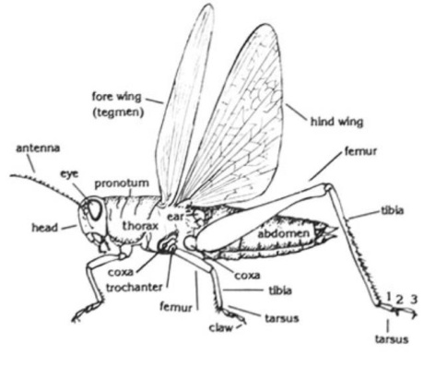

➢ Insects may live in water, on land or in soil, during part of or all of their lives.
➢ Their lifestyle may be solitary, gregarious or highly social.
❖ PEST:
➢ Pests are the organism belonging to class insecta causing economic loss in plants.

